**Clustering Analysis of Utility Energy Consumption by ZIP Code**

Student: Jimmy Ma  
Course: CS777  
Date: February 24th 2025

1. Introduction

Utility energy consumption serves as a vital indicator of regional activity and efficiency. In densely populated states like New York, understanding variations in energy use can inform infrastructure planning, policy decisions, and targeted energy efficiency initiatives. This project employs clustering analysis to investigate whether distinct groups of ZIP codes in New York can be identified based solely on their monthly energy usage data. Using the publicly available Utility Energy Registry – Monthly ZIP Code Energy Usage dataset from New York’s Open Data Portal, the study seeks to uncover natural groupings and explore potential underlying factors—such as urbanization, economic activity, and seasonal influences—that differentiate these clusters.

2. Research Questions and Objectives

Primary Research Question:

* Can clustering analysis reveal distinct groups of ZIP codes based on their energy consumption patterns, and what underlying factors differentiate these groups?

Objectives:

* Determine whether ZIP codes can be segmented into groups representing low, moderate, high, and very-high energy consumption.
* Analyze the distribution of ZIP codes across these clusters to identify potential hotspots of high energy demand.
* Compare results from two clustering approaches—K-Means and Gaussian Mixture Model (GMM)—to evaluate their robustness and interpretability.
* Assess the potential drivers of consumption differences, including geographical factors and seasonal trends.
* Visualize the spatial distribution of clusters using interactive maps and static screenshots to provide geospatial context.

3. Data Description and Preprocessing

3.1 Data Source and Schema

The dataset used in this study is the Utility Energy Registry – Monthly ZIP Code Energy Usage dataset, available in CSV format from [New York’s Open Data Portal](https://data.ny.gov/Energy-Environment/Utility-Energy-Registry-Monthly-ZIP-Code-Energy-Us/tzb9-c2c6). The dataset includes:

* ZIP Code Information: Unique identifiers for each ZIP code.
* Energy Consumption (value): Monthly energy usage measurements.
* Temporal Data: Fields such as year and month.
* Additional Metadata: Fields like data_class, data_field, and others to provide contextual information, including Georeference that provides the location as a POINT (lon lat).

A sample schema produced using PySpark is as follows:

root

|-- year: integer (nullable = true)

|-- data_class: string (nullable = true)

|-- data_field_display_name: string (nullable = true)

|-- data_field: string (nullable = true)

|-- zip_city: string (nullable = true)

|-- month: integer (nullable = true)

|-- zip_code: integer (nullable = true)

|-- state_2: string (nullable = true)

|-- uer_id: integer (nullable = true)

|-- data_stream: string (nullable = true)

|-- utility_display_name: string (nullable = true)

|-- value: double (nullable = true)

|-- number_of_accounts: integer (nullable = true)

|-- Georeference: string (nullable = true)

3.2 Preprocessing Steps

* Cleaning:  
  Rows with missing key fields (e.g., zip_code and value) were removed. The energy usage field was explicitly cast to a double for numerical operations.
* Feature Engineering:  
  A single feature was constructed from the value field using PySpark’s Vector Assembler. No additional features were engineered at this stage, given the focus on energy consumption patterns.
* Data Splitting:  
  The cleaned dataset was split into training (70%) and testing (30%) subsets to ensure that the clustering model’s performance could be evaluated on unseen data.

4. Methodology

4.1 Clustering Algorithms

Two unsupervised learning techniques were used to partition the ZIP codes into distinct clusters:

K-Means Clustering

* Optimal k Determination:  
  The elbow method was applied by computing the within-cluster sum of squared errors (WSSSE) for k values ranging from 2 to 10. A custom function “find_optimal_k” measured the perpendicular distance from each point on the cost curve to the line connecting the first and last points, with the maximum distance indicating the optimal number of clusters. This process yielded an optimal k of 4.

WSSSE:

k = 2 -> Cost (WSSSE): 1.8075191589621676e+16

k = 3 -> Cost (WSSSE): 8515827506267837.0

k = 4 -> Cost (WSSSE): 5030313973413526.0

k = 5 -> Cost (WSSSE): 3393059452511035.0

k = 6 -> Cost (WSSSE): 2375133685017009.0

k = 7 -> Cost (WSSSE): 1819259560531832.2

k = 8 -> Cost (WSSSE): 1455066091651143.0

k = 9 -> Cost (WSSSE): 1192624712760309.8

k = 10 -> Cost (WSSSE): 947631217145830.4

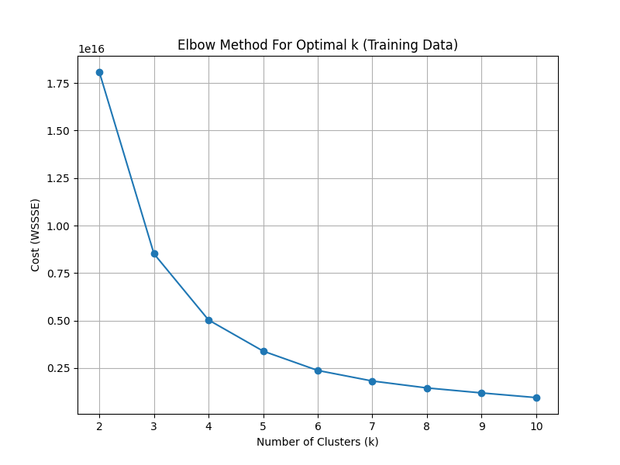

* Model Evaluation:  
  The K-Means model achieved a silhouette score of 0.9661 on the testing set, demonstrating excellent separation between clusters.

Gaussian Mixture Model (GMM)

* Probabilistic Clustering:  
  GMM represents each cluster as a Gaussian distribution and uses Expectation-Maximization (EM) to estimate parameters. With k=4 clusters (to allow direct comparison with K-Means), GMM produced a silhouette score of 0.9265.

4.2 Cluster Labeling and Visualization

After training both models, the cluster centers were sorted by their energy consumption values. Based on the sorted order, clusters were relabeled as:

* Low-Consumption Cluster
* Moderate-Consumption Cluster
* High-Consumption Cluster
* Very-High-Consumption Cluster

Visualizations were generated as follows:  
• Scatter Plots: Displaying clusters with jitter along the y-axis and vertical lines at cluster centers.  
• Heatmaps: Showing binned energy usage frequencies per cluster.  
• Geospatial Maps: An interactive Folium-based map was created to display the spatial distribution of clusters. Screenshots of these interactive maps (saved as PNG) illustrate that upstate areas are predominantly low consumption, whereas NYC exhibits a mix of moderate to very-high consumption.

4.3 CSV Outputs

The final predictions from each model were saved to CSV files:

* kmeans_energy_cluster_output.csv
* gmm_energy_cluster_output.csv

Each CSV includes:

* zip_code: The ZIP code identifier.
* value: The measured energy consumption.
* prediction: The numeric cluster assignment, later mapped to a descriptive label.

5. Results and Detailed Analysis

5.1 K-Means Clustering Results

Cluster Centers (Raw Values)

* Cluster 0: 10,940.83
* Cluster 1: 3,554,447.40
* Cluster 2: 651,134.94
* Cluster 3: 1,731,198.32

After sorting by increasing energy usage, the clusters were assigned as:

* Low-Consumption Cluster: 10,940.83
* Moderate-Consumption Cluster: 651,134.94
* High-Consumption Cluster: 1,731,198.32
* Very-High-Consumption Cluster: 3,554,447.40

CSV Output Insights (K-Means)

The K-Means CSV output reveals that:

* Majority Distribution Most ZIP codes are grouped into the Low-Consumption and Moderate-Consumption clusters, indicating that moderate energy usage is common in New York.
* Target Areas: A smaller number of ZIP codes fall into the High and Very-High clusters, likely representing urban or industrial zones that may be prioritized for energy efficiency programs.

Visualizations

* Scatter Plot: The scatter plot displays distinct, non-overlapping clusters with clear separation along the energy usage axis. Each cluster’s vertical marker (representing the center) helps validate the cluster boundaries.

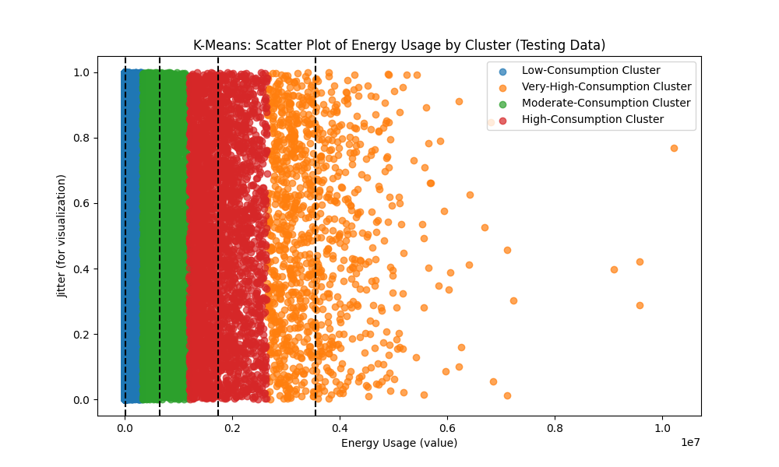

* Heatmap: The heatmap confirms that energy usage frequencies vary significantly by cluster, further validating the effectiveness of the clustering.

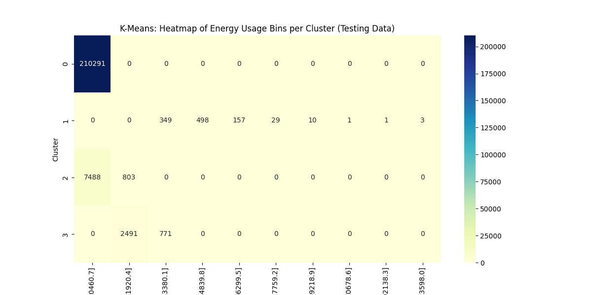

* Geospatial Map: An interactive Folium map shows that upstate areas are predominantly low consumption (green markers), while NYC shows a mix of moderate, high, and very-high consumption (blue, orange, red markers).

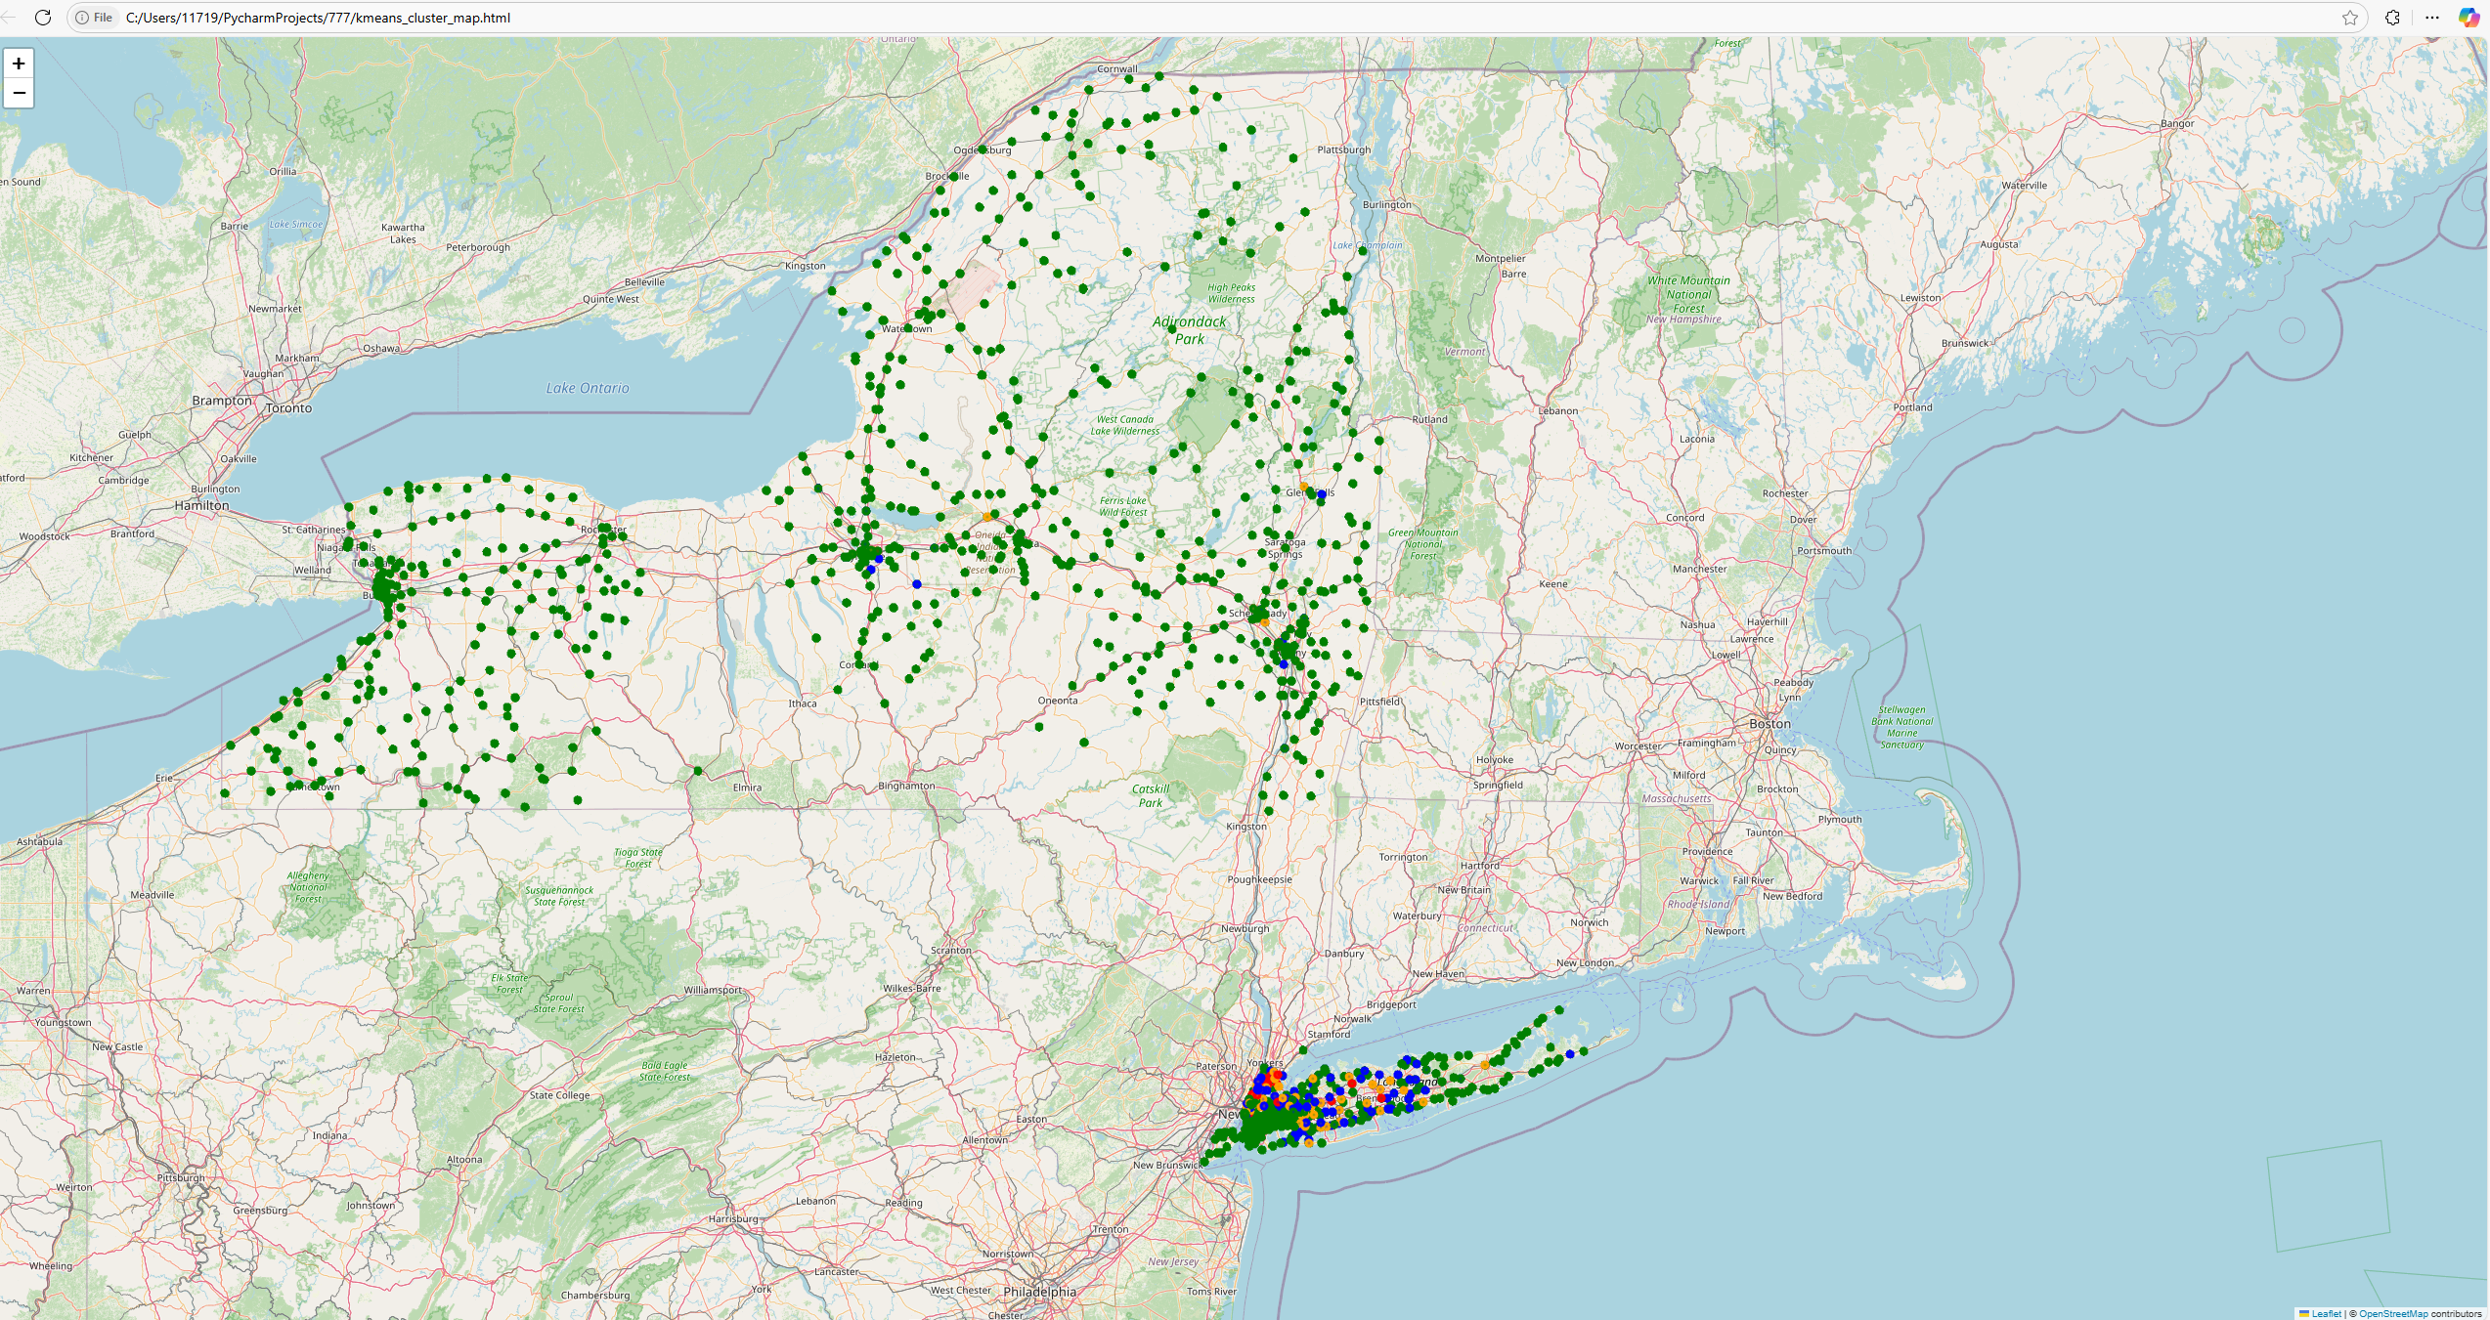

5.2 GMM Clustering Results

Cluster Centers (Raw Values)

* Cluster 0: 256,325.05
* Cluster 1: 2,840.66
* Cluster 2: 2,488,824.70
* Cluster 3: 1,001,461.68

After sorting:

* Low-Consumption Cluster: 2,840.66
* Moderate-Consumption Cluster: 256,325.05
* High-Consumption Cluster: 1,001,461.68
* Very-High-Consumption Cluster: 2,488,824.70

CSV Output Insights (GMM)

The GMM CSV output, while showing a similar overall segmentation, presents slight differences:

* Distribution Consistency: As with K-Means, most ZIP codes fall into the Low- and Moderate-Consumption groups.
* Model Sensitivity: The small discrepancies between the K-Means and GMM cluster centers (and subsequent ZIP code assignments) highlight the sensitivity of clustering outcomes to the underlying model assumptions. GMM’s probabilistic approach captures uncertainty and overlapping cluster boundaries, which may be beneficial for certain downstream analyses.

Visualizations

* Scatter Plot and Heatmap: Like the K-Means results, the scatter plot for GMM displays distinct clusters with well-defined centers. The heatmap reinforces the energy usage distribution across clusters, corroborating the CSV output findings.

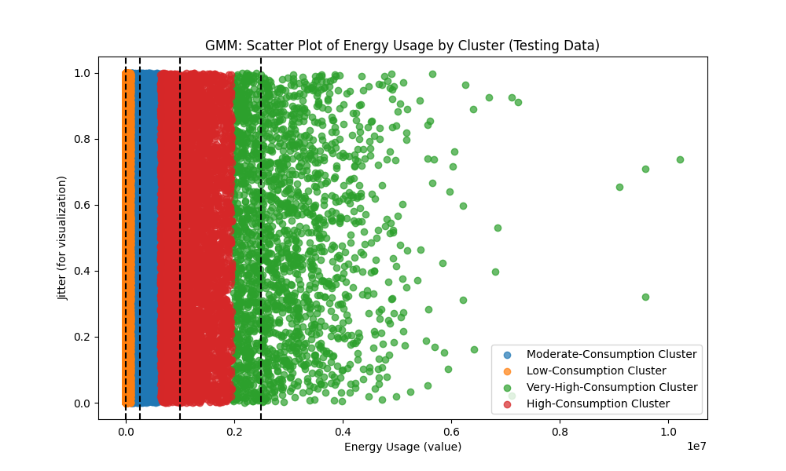

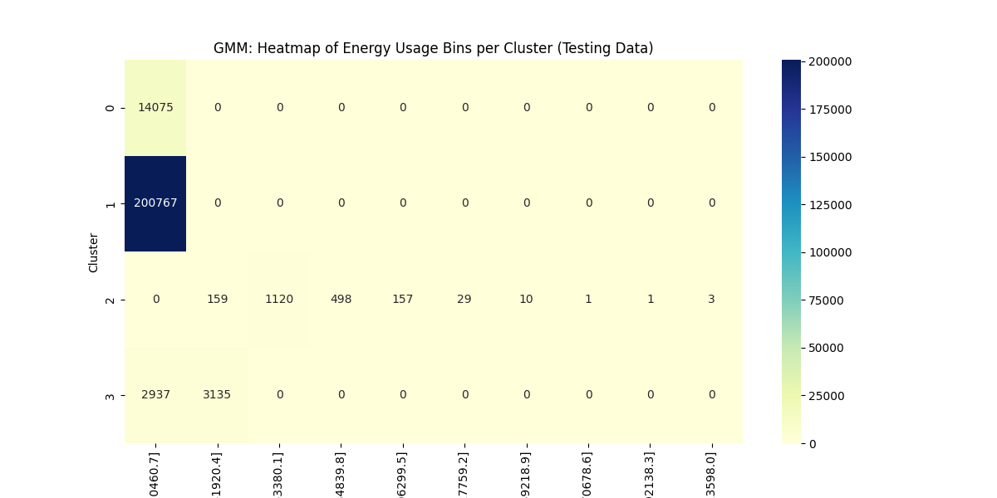

* Geospatial Map: The interactive Folium map highlights similar regional patterns as K-Means, confirming the segmentation across New York.

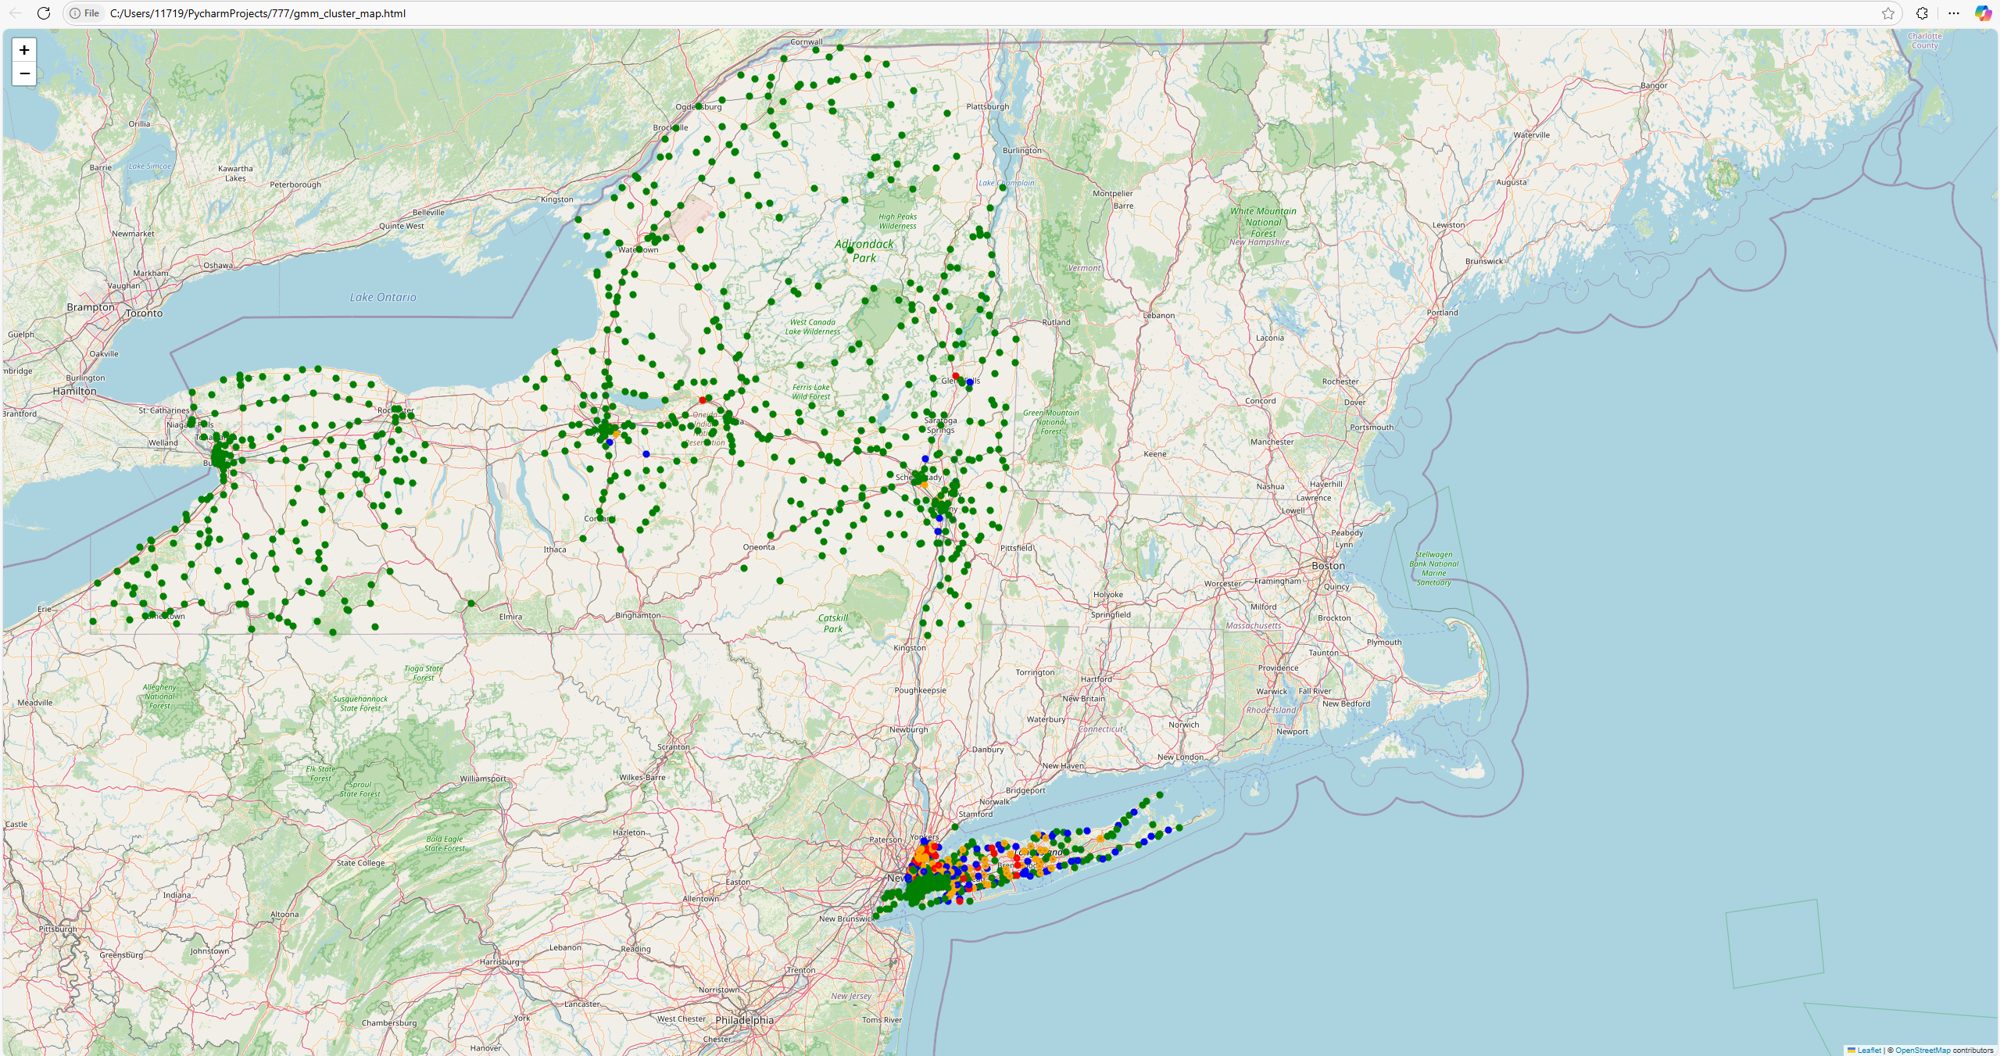

5.3 Comparative Analysis: K-Means vs. GMM

Methodological Differences:  
K-Means:

* Hard assignments with spherical clusters.
* High silhouette score (0.9661) and crisp boundaries.

GMM:

* Soft, probabilistic assignments with elliptical clusters.
* Slightly lower silhouette score (0.9265) but captures uncertainty in overlapping areas.

Cluster Center Characteristics:  
• K-Means centers clearly delineate the consumption tiers, whereas GMM centers are slightly shifted due to weighted probabilistic assignments.

Distribution of Cluster Assignments:  
• Both methods largely agree, with most ZIP codes falling into the Low and Moderate clusters.  
• GMM’s soft assignments offer nuanced insights for borderline cases.

Silhouette Score Comparison:  
• K-Means: 0.9661  
• GMM: 0.9265

Implications:  
Both models reliably identify four distinct consumption segments, and the geospatial maps reinforce these findings by showing that high-consumption areas are predominantly in urban regions.

6. Discussion

Key Observations:  
• Dominant Clusters: Most ZIP codes are in the Low and Moderate clusters, reflecting common residential usage.  
• Outlier Regions: High and Very-High clusters, though fewer, indicate urban centers or industrial zones. • Model Comparison: K-Means yields sharper, more distinct boundaries, while GMM captures overlap and uncertainty, offering complementary insights.

Implications for Policy and Utility Management:  
• Targeted Interventions: ZIP codes in the High and Very-High clusters can be prioritized for energy efficiency programs and infrastructure investments.  
• Further Data Integration: Merging the clustering outputs with demographic, economic, or weather data could enhance understanding and intervention strategies.

7. Conclusion

The project demonstrates that clustering analysis is an effective tool for segmenting ZIP codes in New York based on energy consumption patterns. Both K-Means and GMM identified four distinct clusters corresponding to low, moderate, high, and very-high energy usage, with high silhouette scores confirming the robustness of the groupings. The inclusion of geospatial visualization via interactive Folium maps provides valuable context by revealing that while most regions exhibit moderate energy demand, urban areas often display significantly higher consumption.

In summary:  
• Clustering reveals meaningful segments.  
• The results offer actionable insights for targeted energy efficiency programs and infrastructure investments.  
• Future work will focus on integrating additional features and extending the analysis temporally.